Functioneel ontwerp

Project Lode Runner

Martin Steenbergen AM3B

# Inhoud

Schermen structuur 4

Main Menu 5

Choose difficulty 6

Ingame Menu 7

Highscores 8

Game Over 9

# Schermen structuur

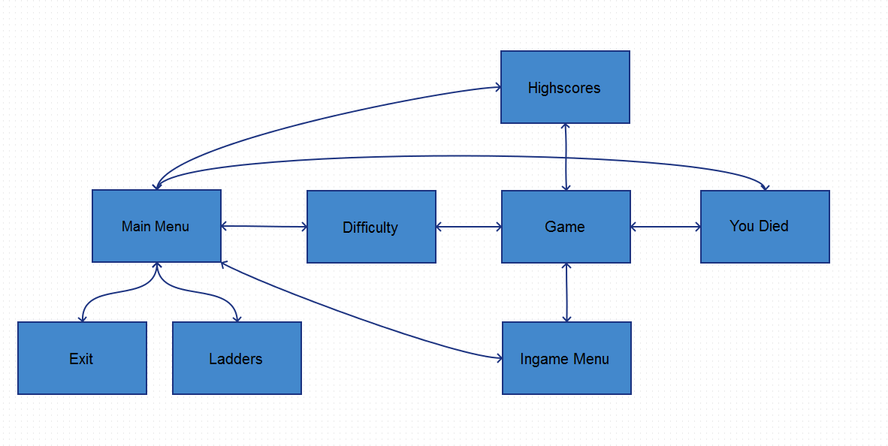

# Main Menu

# Choose difficulty

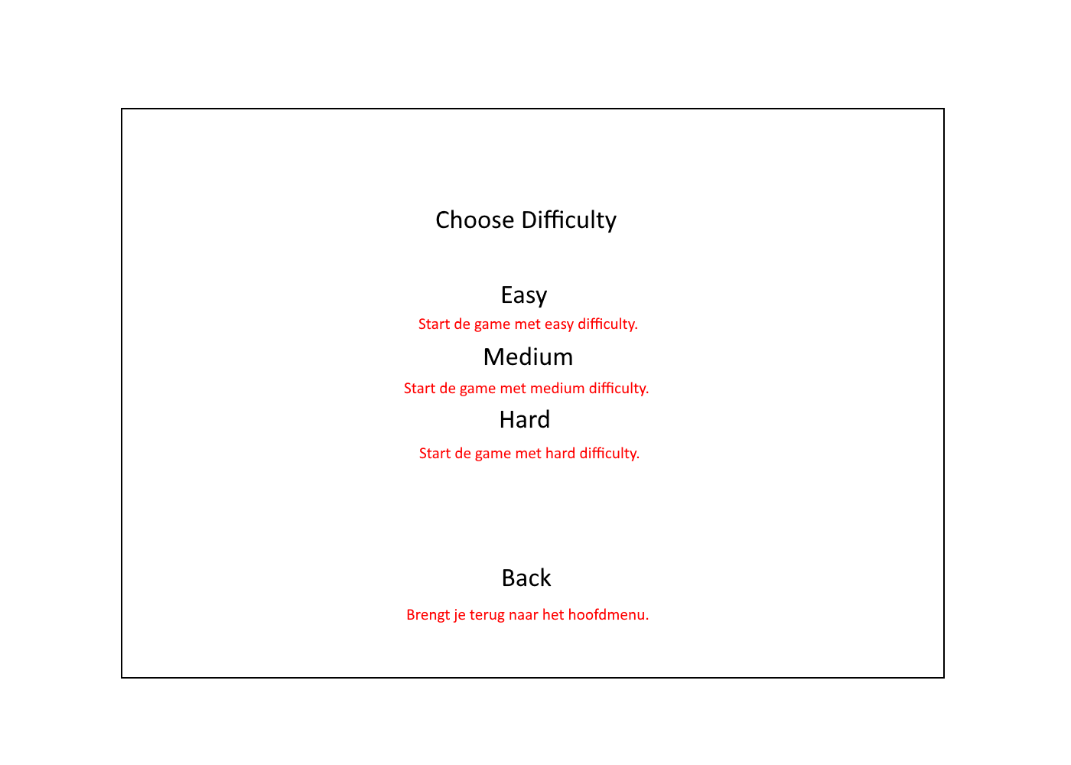

# Ingame Menu

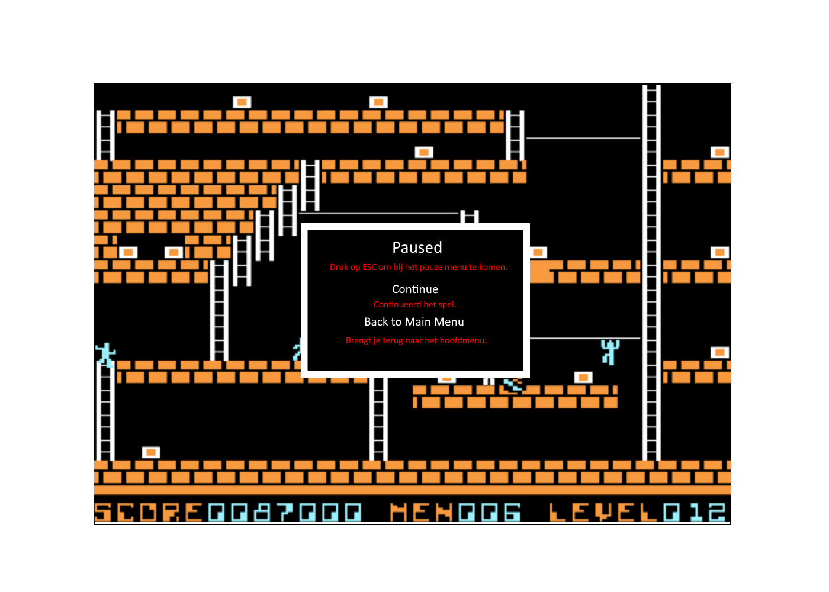

# Highscores

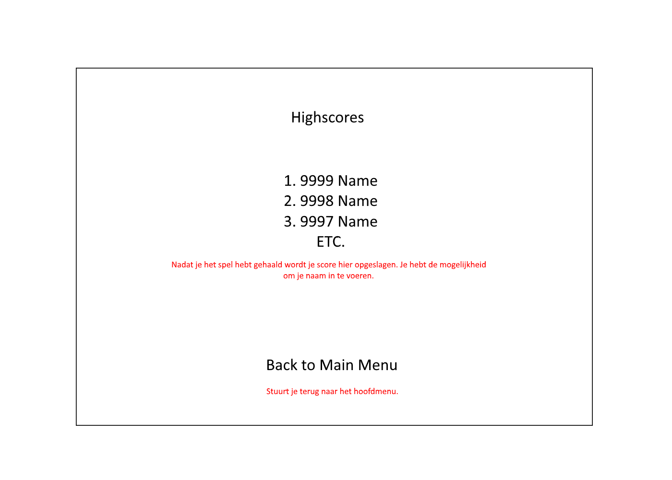

# Game Over

